IPSWICH BICYCLE CLUB
https://ipswichbicycleclub.co.uk/

Open 10 mile Time Trial

Crowfield Circuit (CTT Course No. B10/32)

Promoted for and on behalf of Cycling Time Trials under their Rules and regulations on:

Saturday 28th May 2022 (14:00)

Officials:

Time Keeping:

Mr Angus Jardine Mr Mark Salter

Marshals and Helpers:

Members and friends of IBC

Event Secretary:

Jon Carlyon

123 Parliament Road

IPSWICH

IP45EP

Email: carljonath@aol.com

Mobile: 01910 802047

Event HQ

Crowfield Village Hall, Ipswich, IP6 9SZ

B10/32 Course
START at southernmost white post at entrance to water tower at Crowfield going towards Hemingstone. Take second left (1.8 miles), WITH CARE onto Gosbeck road and continue north through Gosbeck to junction with B1077, where bear left past Framsden Windmill to junction with A1120. Turn left and continue to Pettaugh, where turn left onto Crowfield road continue to FINISH approx. 100 yds past Rose PH, in line with yellow hydrant on opposite side of road at entrance to New Hall.
No warming up on the course direction once the event has started.
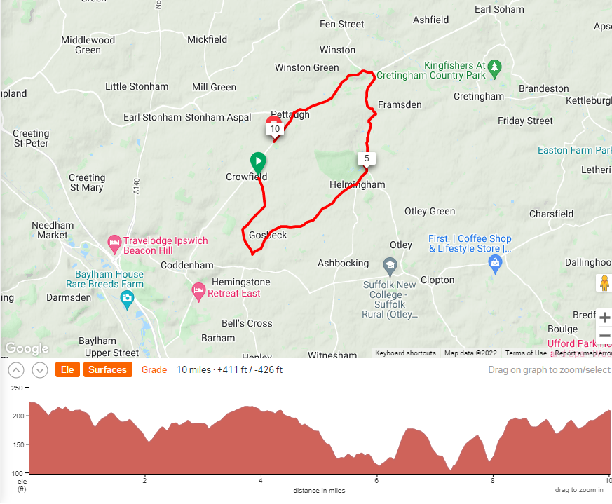
Course records
Male – Ross Fawcett (Pedal Power RT) 21:04 (2nd Jun 2018)
Female – Becky Johnson (Stowmarket & District CC) 24:12 (15th May 2018)

Directions to start
Turn Right out of HQ then Right onto Ipswich Road to start by Water Tower

EAST DISTRICT REGULATIONS

U Turns will not be permitted on courses or roads adjacent to the start and finish areas whilstthe race is in progress. WARMING UP No warming up along the course by competitors once the event has started. Turbo trainers: The use of turbo trainers is banned at all events with an AM start time. (Theroad between the HQ and the start provides a perfect road to warm up on). Note: Any breaking of the above regulations, in the first case, may mean disqualification from the event. Further cases will be reported to the District Committee. Numbers will be at the HQ and not at the start. All competitors must sign-in and sign-out.

CYCLE HELMETS

All competitors must wear a properly affixed helmet which must be of hard/soft shell construction. Helmets should conform to a recognised Standard such as SNELL B95, ANSI Z90.

Working FRONT & REAR LIGHTS

(j) No competitor shall be permitted to start either a Type A or Type B event unless such competitor has affixed to the front of their machine a working front white light, either flashing or constant, that is illuminated and in a position that is clearly visible to other road users.

“No competitor shall be permitted to start either a Type A or Type B event unless such competitor has affixed to the rear of their machine a working rear red light, either flashing or constant, that is illuminated and in a position that is clearly visible to other road users.”

Prizes

Scratch

1st £20

2nd £15

3rd10

Fastest Lady

£20

Vet on standard

1st £20

2nd £15

3rd £10

